**DAILY ONLINE ACTIVITIES SUMMARY**

|  |  |  |  |  |  |  |  |
| --- | --- | --- | --- | --- | --- | --- | --- |
| **Date:** | **04 June 2020** | | | | **Name:** | **KHATHEEJA SAFREENA** | |
| **Sem & Sec** | **4th sem, 2nd year** | | | | **USN:** | **4AL18CS037** | |
| **Online Test Summary** | | | | | | | |
| **Subject** | | **MICROCONTROLLER AND EMBEDDED SYSTEM (18cs44)** | | | | | |
| **Max. Marks** | | **20** | | **Score** | | **15** | |
| **Certification Course Summary** | | | | | | | |
| **Course** | **GAME DEVELOPMENT USING PYGAME.** | | | | | | |
| **Certificate Provider** | | | **GUVI.** | **Duration** | | | **7 hours** |
| **Coding Challenges** | | | | | | | |
| **Problem Statement:2 program** | | | | | | | |
| **Status: Executed** | | | | | | | |
| **Uploaded the report in Github** | | | | **Yes** | | | |
| **If yes Repository name** | | | | **[http://shafreenasharief / lockdown-coding](http://shafreenasharief / lockdown-coding" \o "http://shafreenasharief / lockdown-coding)**  **[http://shafreenasharief / locked-down--certification-course](http://shafreenasharief / locked-down--certification-course" \o "http://shafreenasharief / locked-down--certification-course)**  **[http://github.com/shafreenasharief/Daily_Report](http://github.com/shafreenasharief/Daily_Report" \o "http://github.com/shafreenasharief/Daily_Report)** | | | |
| **Uploaded the report in slack** | | | | **Yes** | | | |

Online Test Details: (Attach the snapshot and briefly write the report for the same)

Certification Course Details: (Attach the snapshot and briefly write the report for the same)

Coding Challenges Details: (Attach the snapshot and briefly write the report for the same)

**ONLINE TEST SUMMARY:**

Today **MICROCONTROLLER AND EMBEDDED SYSTEM (18cs44)** was conducted of first module. Total marks for the test was 20.

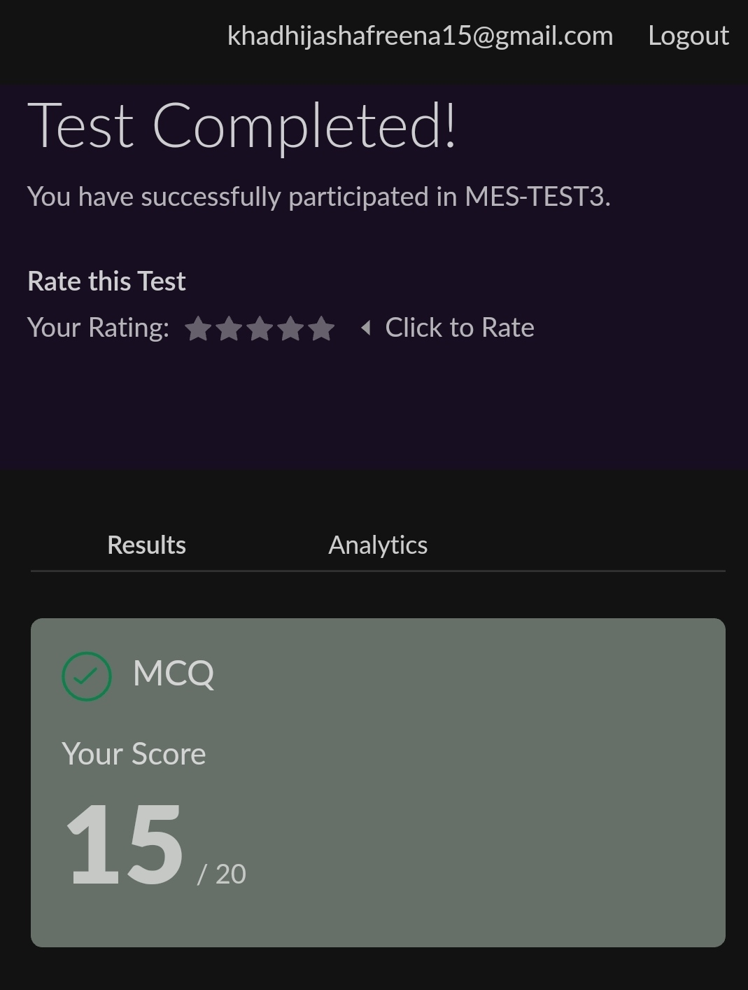

**CERTIFICATION COURSE SUMMARY:**

Today I started certificate course on **'GAME DEVELOPMENT USING PYGAME'**, through **GUVI**.The course was scheduled for 7 hrs .I completed first five topics.I attempted quiz ,which gave me a clear veiw about the topics that were thought and discussed.It consists of 10 modules which also include assessments.

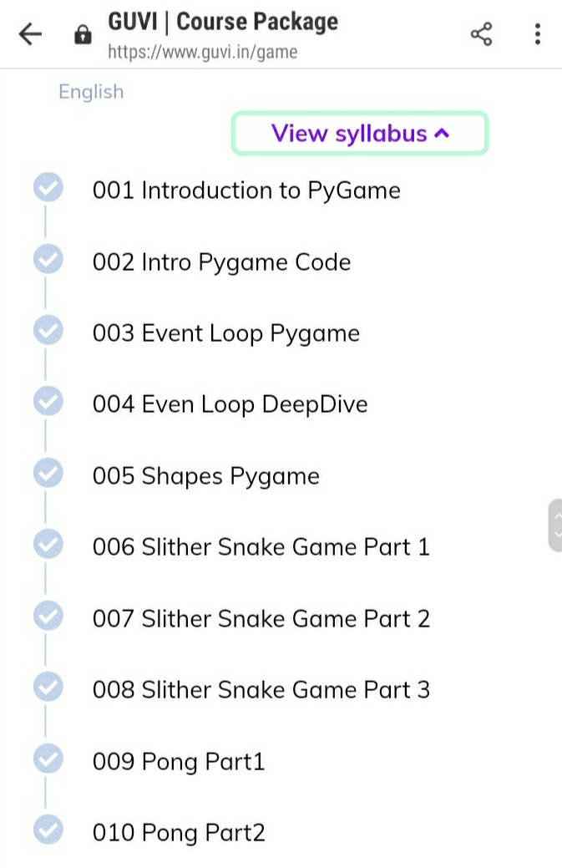

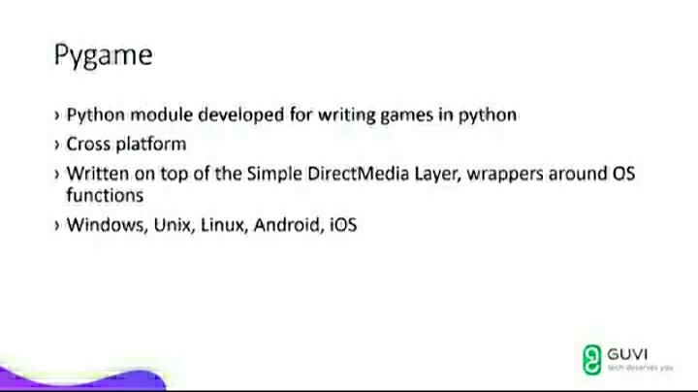

**CODING CHALLENGE:**

Today I solved 2 coding challenge,

**1.** **write a java program to read three integer values from the keyboard and find the sum of the values. Declare a variable "sum" of type int and store the result in it.**

**2. Write a C++ program to find the missing number in array**

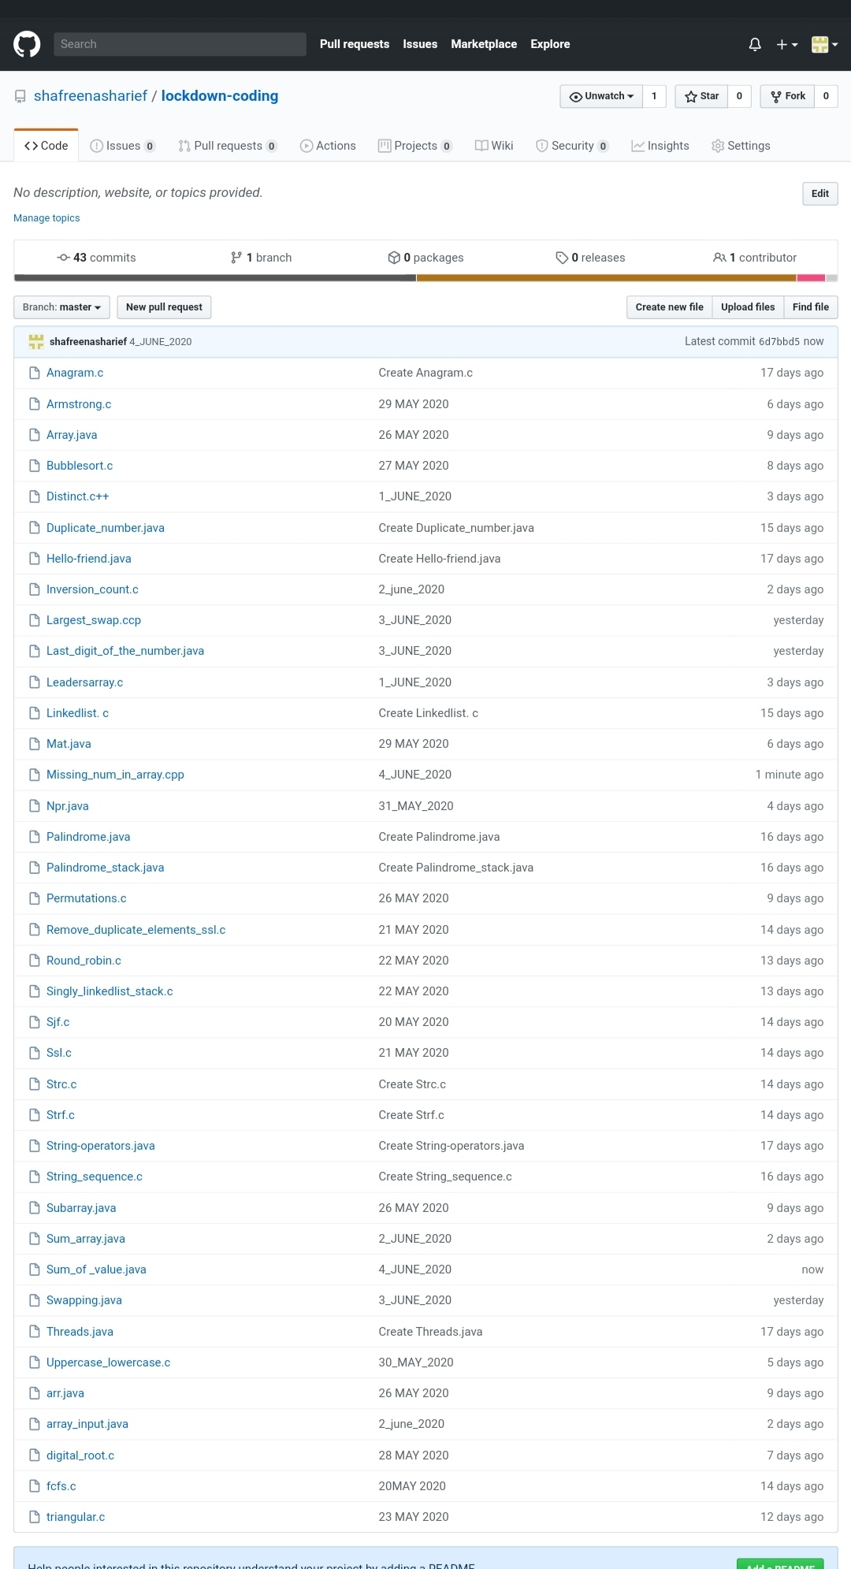

**SOLUTION : I have uploaded the solution of the above 3 coding problems in my GitHub repository.**

**http://shafreenasharief / lockdown-coding**

**http://shafreenasharief / locked-down--certification-course**

**http://shafreenasharief / Daily_Report**